📄 📘 SUPERSTORE DATA ANALYSIS REPORT

🟣 1. Title Page
Superstore Data Analysis Dashboard
Using Python, SQL and Power BI
Name: Prince Kr Giri
Course: B.Tech CSE(CYS)
Date: 25-03-2026

🟣 2. Abstract
This project focuses on analyzing the Sample Superstore dataset obtained from Kaggle. The objective of the project is to perform end-to-end data analysis using Python, SQL, and Power BI.
The dataset was cleaned and preprocessed using Python. SQL was used to perform structured queries and extract meaningful insights. Finally, an interactive dashboard was developed in Power BI to visualize key business metrics such as sales, profit, and customer segments.

🟣 3. Dataset Description
The dataset used in this project is the “Sample Superstore” dataset, which contains sales transaction data.
Main Columns:
- Order ID
- Order Date
- Ship Date
- Customer Name
- Region
- Category and Sub-Category
- Sales, Profit, Discount, Quantity
👉 [Dataset Preview] 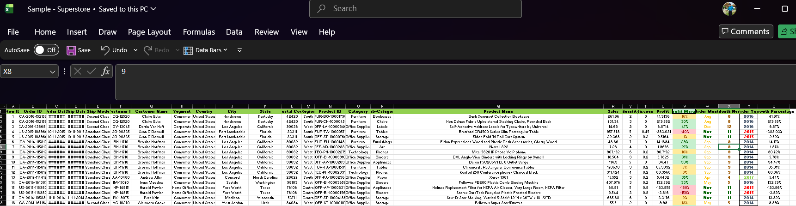

🟣 4. Data Preprocessing (Python)
Data preprocessing was performed using Python libraries such as Pandas.
Steps performed:
- Handled missing values
- Removed duplicate records
- Converted date columns into proper datetime format
- Created new features:
  - Year, Month
  - Profit Margin
  - Shipping Days
  - Discount Level (Low, Medium, High)
👉 [Screenshots of Python Code / Output] 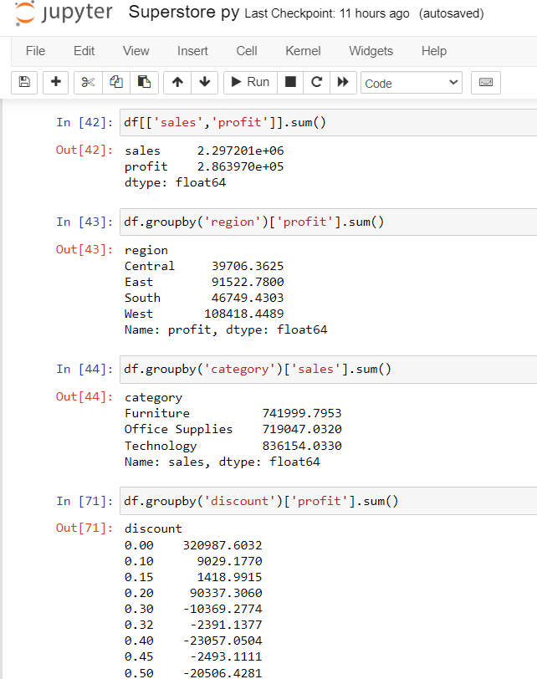

🟣 5. Exploratory Data Analysis (EDA)
Exploratory Data Analysis was conducted to understand patterns and trends in the dataset.
Key analysis performed:
- Total Sales and Profit
- Sales by Category
- Region-wise performance
- Time-based sales trends
- 👉 Screenshot: Python Graphs
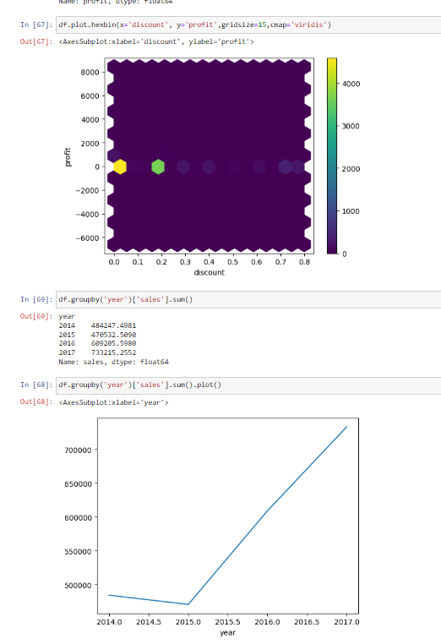

🟣 6. SQL Analysis
SQL was used to perform structured queries on the dataset.
Tasks performed:
- Created table and imported dataset
- Calculated total sales and profit
- Identified top-performing products
- Analyzed region-wise performance
- Screenshot: SQL Queries + Output
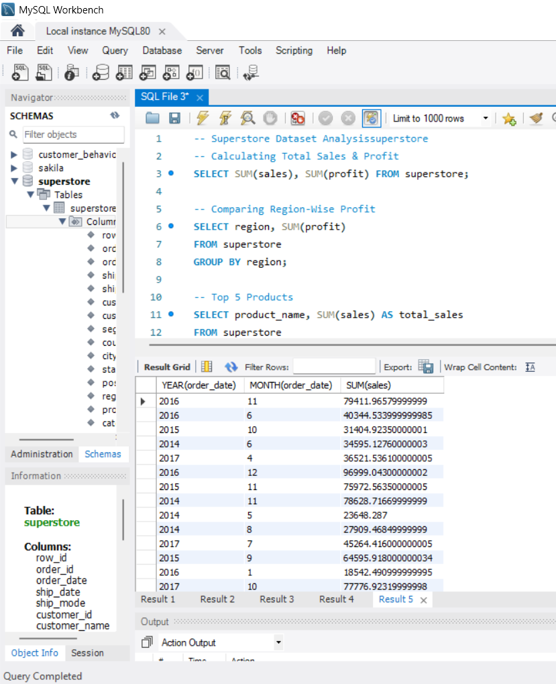

🟣 7. Data Integration
The processed dataset was connected to Power BI for visualization.
Steps:
- Imported dataset into Power BI
- Established connection with SQL database
- Loaded cleaned data for dashboard creation

🟣 8. Dashboard Development
An interactive dashboard was created using Power BI.
Dashboard includes:
- KPIs:
  - Total Sales
  - Total Profit
  - Total Orders
- Visualizations:
  - Sales by Category (Bar Chart)
  - Sales by Segment (Pie Chart)
  - Sales by Region (Map)
  - Sales Trend (Line Chart)
  - Discount vs Profit (Scatter Plot)
  - Top Products Table
- Slicers:
  - Region
  - Segment
  - Order Date
- Screenshot: Final Dashboard
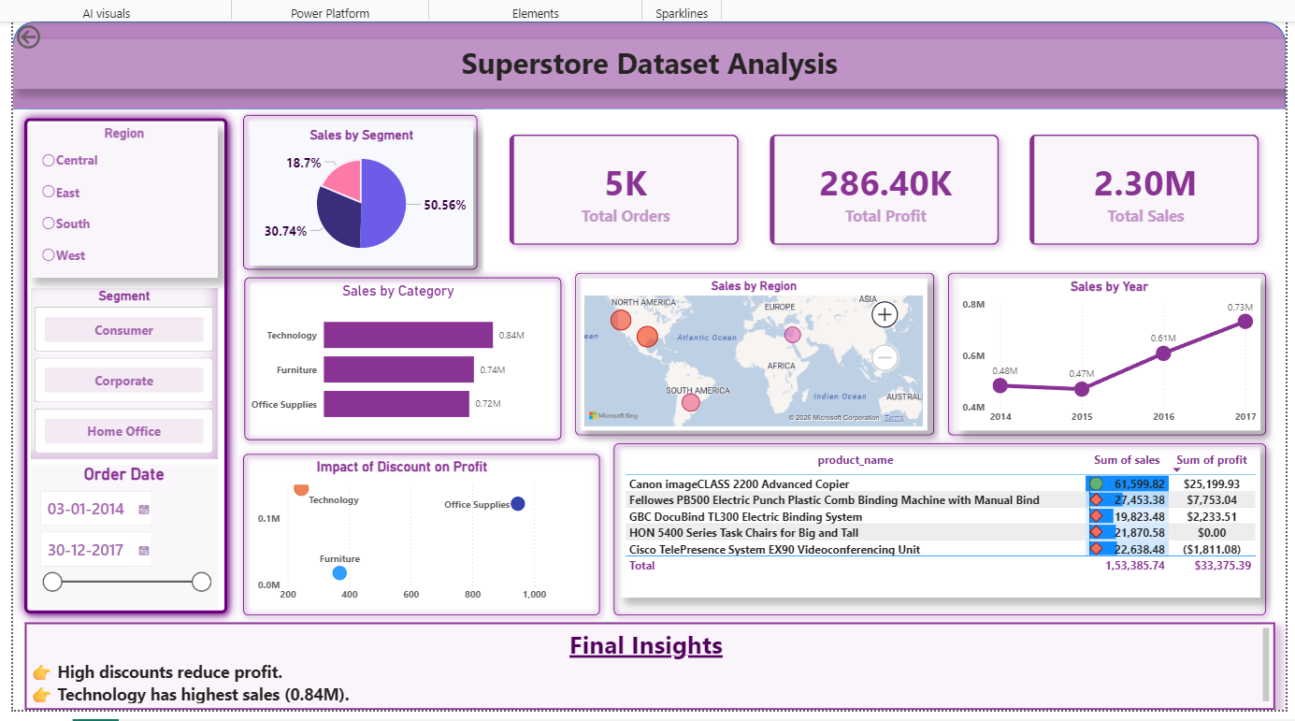

🟣 9. Key Insights
- High discounts negatively impact profit.
- Technology category generates the highest sales.
- Sales show a consistent increase over the years.
- Certain regions contribute more to overall profit.

🟣 10. Conclusion
This project demonstrates how data analysis techniques can be used to extract meaningful insights from raw data. The dashboard helps in identifying key business trends and supports decision-making.
By combining Python, SQL, and Power BI, a complete end-to-end data analysis workflow was achieved.

🟣 11. Tools Used
- Python (Pandas, Matplotlib, Seaborn)
- SQL (MySQL/PostgreSQL)
- Power BI

🟣 12. Thank You!

